|  |  |  |
| --- | --- | --- |
| République du Cameroun  ****** |  | Republic of Cameroon  ****** |
| Ministère de l’enseignement supérieur  ****** | Ministry of higher education  ****** |
| Paix-Travail-Patrie  ****** | Peace-Work-Fatherland  ****** |
| SAINT JEAN INGENIEUR  ****** | SAINT JEAN INGENIEUR  ****** |
| Academic year 2024-2025 | | |

**Group members:**

* ABENA ALEX NELSON RYAN
* AYUK NJIEASSAM MA-NDIEP
* CHAYONG TINDO CLAUDIA
* MFONE MBOUNGAM AHMAD AMINE

**Supervised by**

* ARTHUR PESSA
* EMMANUEL MOUPOJOU

**Title:**

Design document for BTP Sarl Construction Management Web Application

**EU Title**: ISI Transversal Project, Techdays

**EU code**: ING 3166

Contents

**Context** 1

**Introduction** 1

**1.** **Methodology Used** 2

4+1 View Model 2

**2.** **Sequence Diagrams** 3

**3.** **Class diagram** 3

**4.** **Activity diagram** 3

**5.** **State Machine Diagram** 3

a. The whole system life cycle 3

b. Construction project life cycle 3

c. Material request life cycle 3

**Conclusion** 4

# **Context**

BTP Sarl is a company that manages and monitors construction projects. One of its main concerns is tracking the input and output of construction materials. The goal is to develop a web application that enables real-time traceability of construction project management and monitoring from tablets or computers. This project can be used in the field of civil engineering.

# **Introduction**

This document provides the software design specifications for a **real-time construction work monitoring and project management system**. The system is intended to facilitate efficient tracking of construction activities, management of construction materials and financial transactions, and real-time documentation of project progress.

# **Methodology Used**

## 4+1 View Model

For our design, we will use the **4+1 View Model**, a software architecture methodology that utilizes five complementary views to describe the system. Each view provides a different perspective, ensuring comprehensive coverage of both static and dynamic aspects.

**Description of the 4+1 Methodology**

The **4+1 View Model** consists of:

|  |  |  |
| --- | --- | --- |
| View | Diagram | Purpose |
| Logical View | Class Diagram | Shows the static structure of classes and their relationships. |
| Process View | Sequence Diagram | Shows dynamic interactions between objects over time. |
| Development View | Activity Diagram | Represents workflows and processes in the system. |
| Physical View | State Transition Diagram | Shows how system states transition over time (replacing Deployment Diagram). |
| Scenarios (+1) | Use Case/Sequence Diagram | Validates the architecture by showing how the system behaves in scenarios. |

NB: In our case, the **Deployment Diagram** will be replaced by the **State Transition Diagram** due to project constraints.

# **Sequence Diagrams**

# **Class diagram**

# **Activity diagram**

# **State Machine Diagram**

## The whole system life cycle

**States**

* Development
* Testing
* Deployed

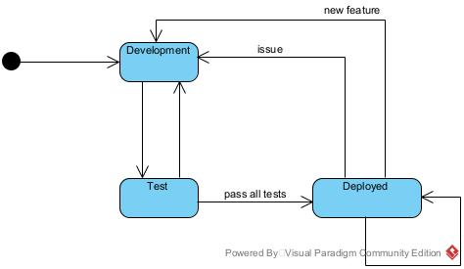

## Construction project life cycle

**States**

* Created
* Assigned to User
* Started
* Ongoing
* Cancelled
* Completed

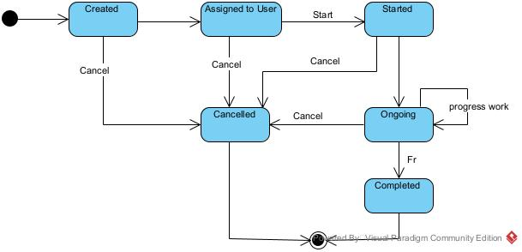

## Material request life cycle

**States**

* Created
* Confirmed
* Rejected
* Recorded

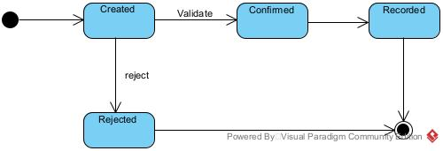

# **Conclusion**

This document presents the **real-time construction monitoring and project management system** using the **4+1 View Model**. The design ensures efficient tracking of construction activities, materials, and financial transactions. By integrating user roles, workflows, and structured data management, the system will improve project oversight and decision-making.